Assignment 1

Write a dataclass describing a mountain (containing fields for name and elevation) and:
- Construct an instance of the dataclass
- Convert it to string

Solution

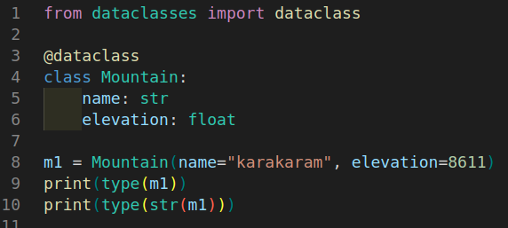
- In first line we import the dataclass from dataclasses library.
- Than we use dataclass annotation @dataclass.
- After that we write our Mountain class and it’s fields.
- Than we construct the instance of Mountain class.
- Now, we print the type of instance.
- In last, we type cast the instance of Mountain to str and print pint its type.

